Step 1: Go to the Google Developers Console. https://console.developers.google.com/apis/library

Step 2: Select a project, or create a new one.

Step 3: In the list of API click "Analytics API". Make sure the status is Enable for the Analytics API.

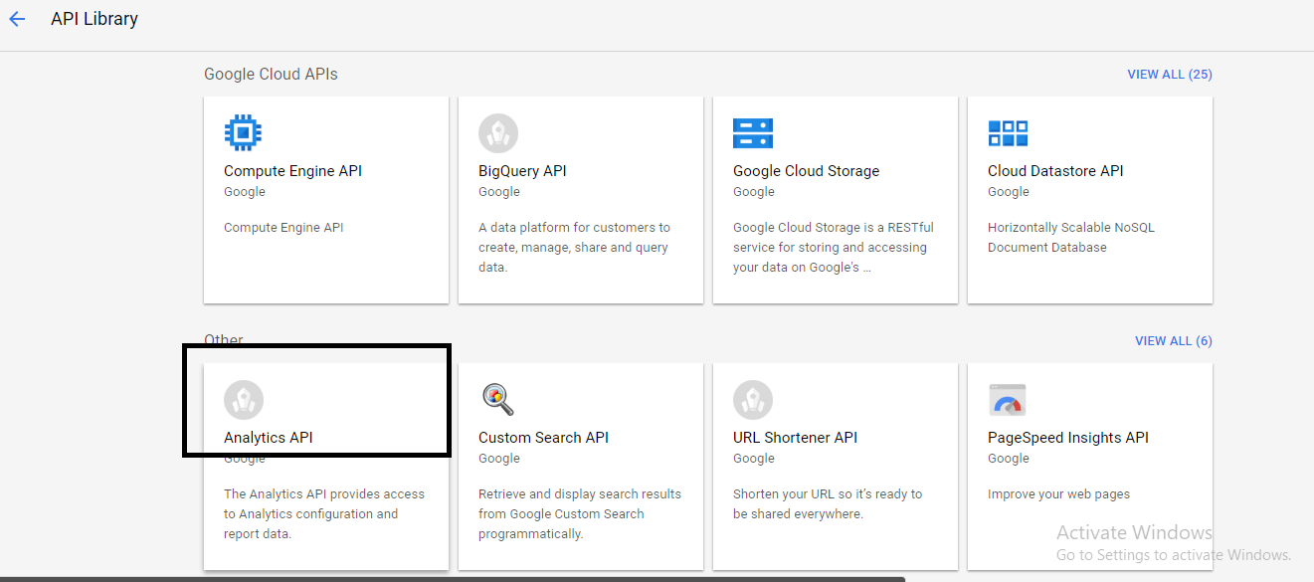

Step 4: In the sidebar on the left, select Credentials.

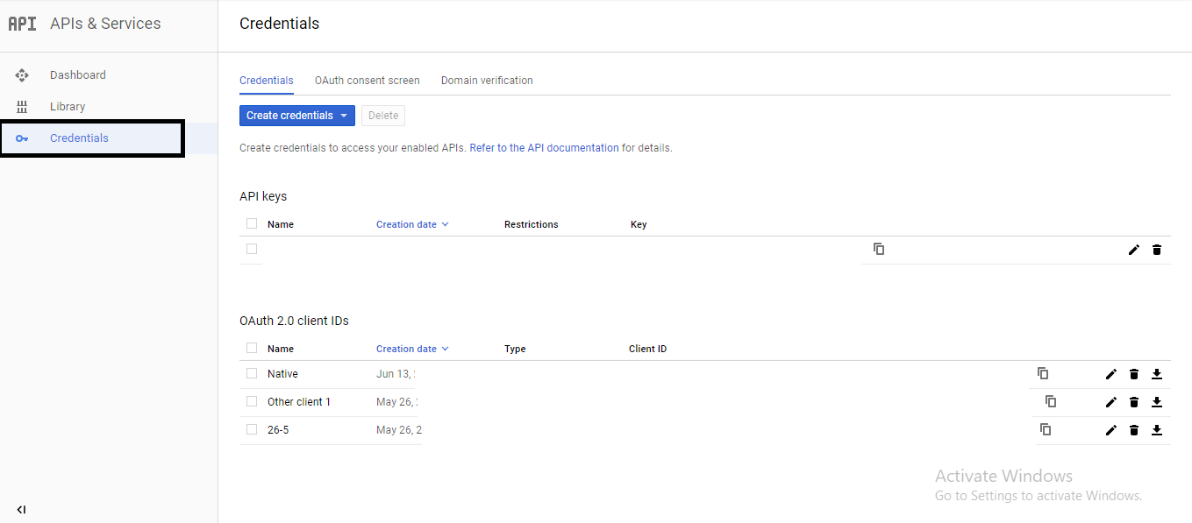

Step 5: Click on "Create credentials" and then "OAuth client ID".

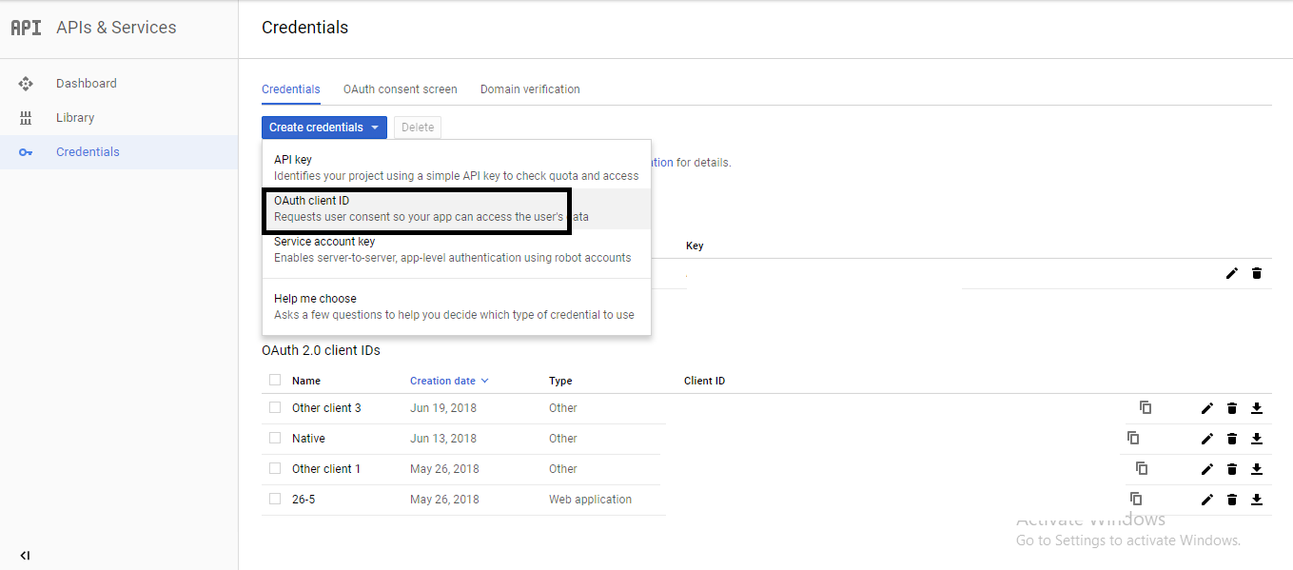

Step 6: Select Other and give name of your app.

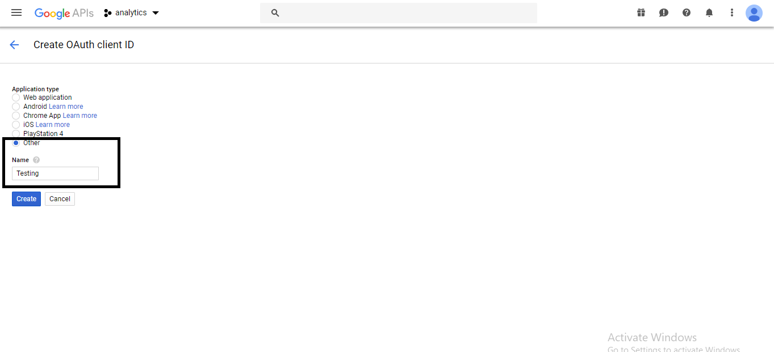

Step 6: Download your json file.

